Lab5 – RDS Responsibility
Task 1
Create a MySQL
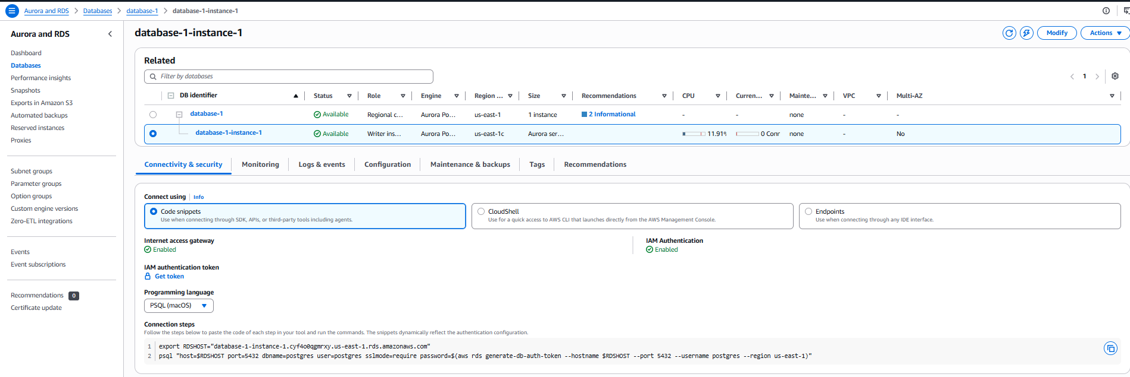
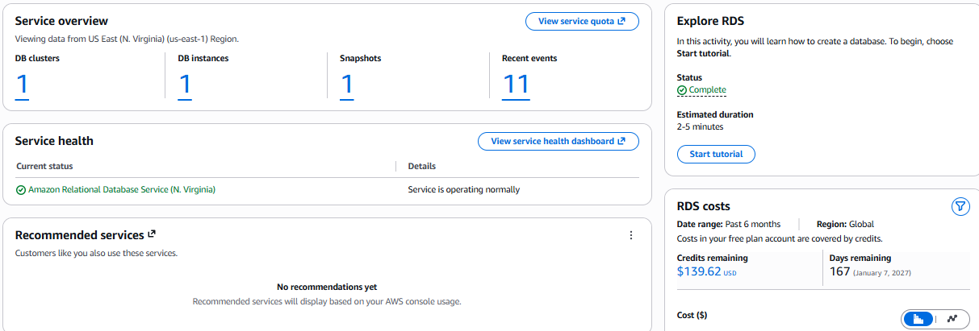

Snapshot
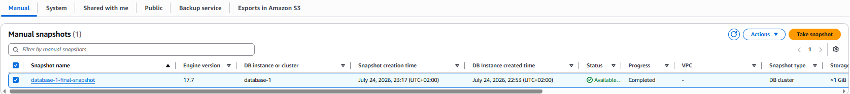
Events
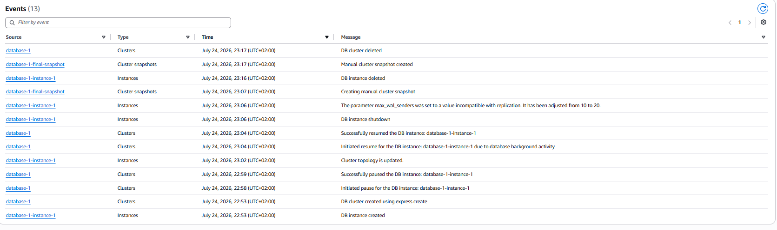
Delete Snapshot
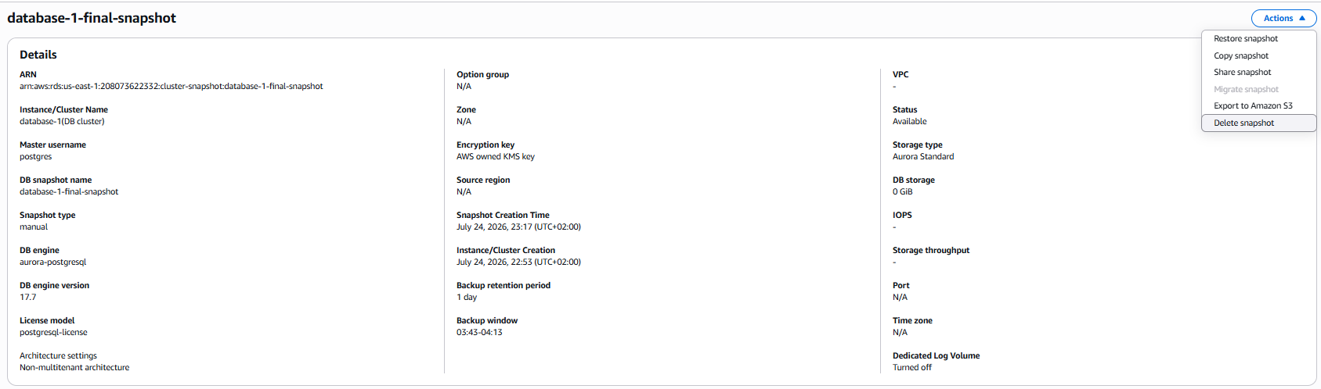
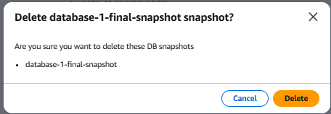

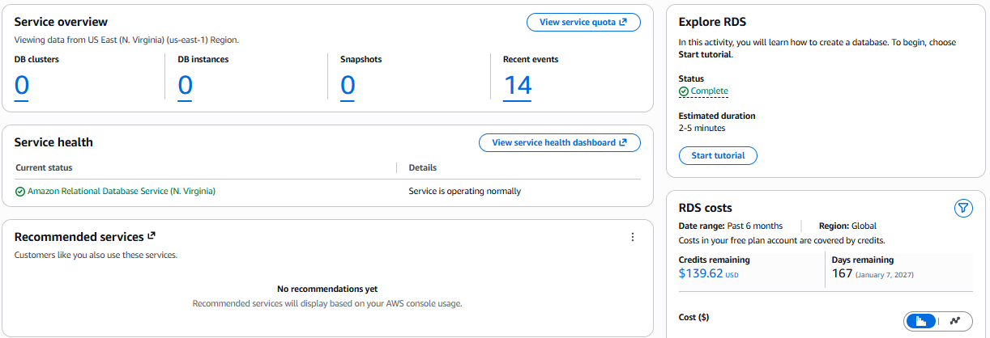

Task 2
Managed by AWS | AWS | Customer
Operating System
Database Software Installation
Hardware

Task 3
Managed by Customer | AWS | Customer
Master Username
Master Password
Database Permissions
Encryption
Backups
Network Access

